6- Selenium

Get Methods:
We can access these methods through webdriver instance; works on web pages. That's why getText() won't come in this category.

get(url) - opens the url on the browser
getTitle() - returns title of the page
getCurrentUrl() - retuns URL of the page
getPageSource()- returns source code of the page
getWindowHandle() - returns ID of the single Browser window
getWindowHandles() - retuns ID's of the multiple browser windows --> useful when navigating to specific browser window or closing certain browser window.

Note: When we open a new browser window also, the operations further we perform will affect the origin browser window only unless until we navigate to the new browser window.

1)get(url)
opens the url on the browser
driver.get("https://testautomationpractice.blogspot.com/");
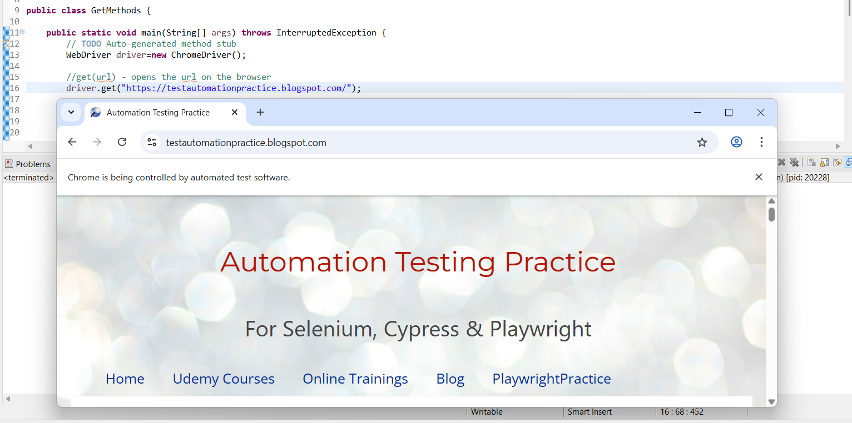

2) getTitle() - returns title of the page
System.out.println(driver.getTitle());

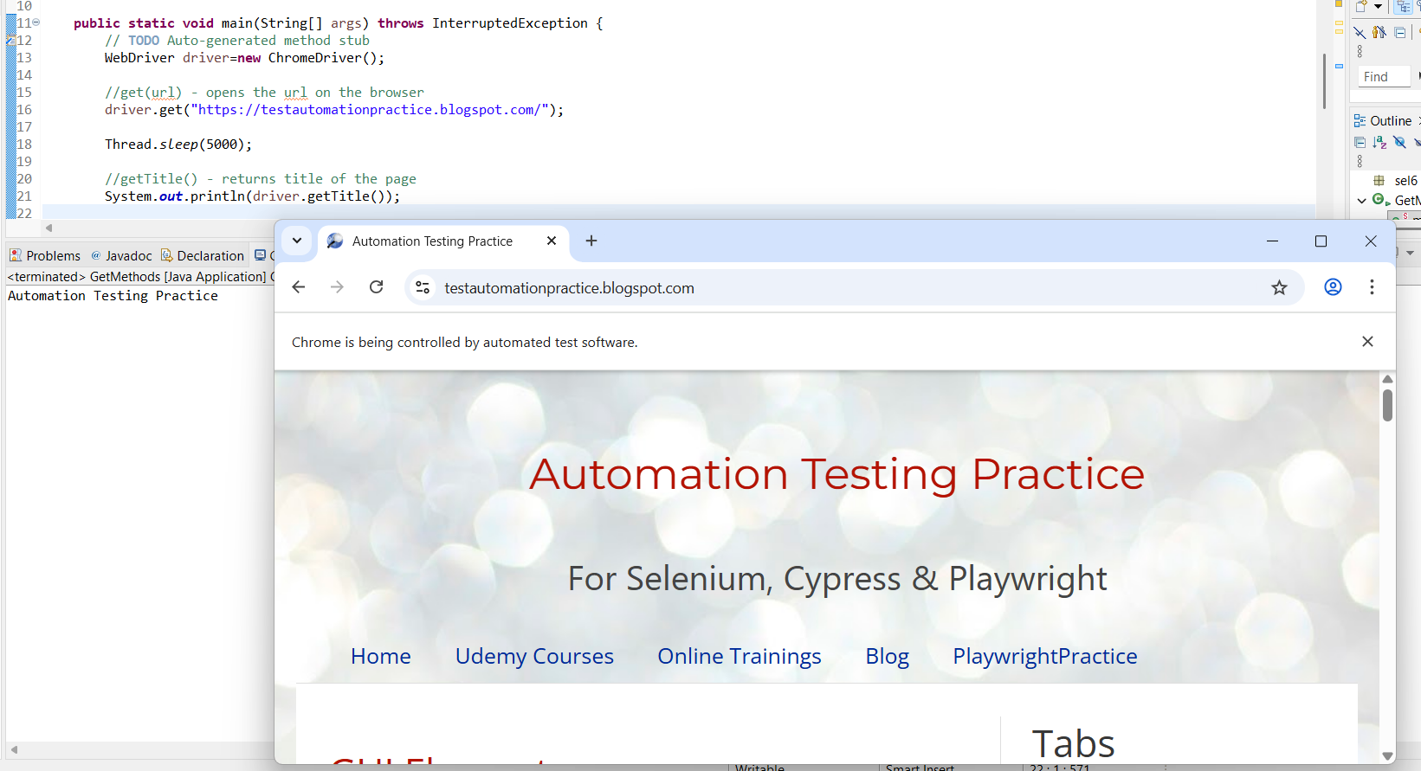
3) getCurrentUrl() - returns URL of the page
System.out.println(driver.getCurrentUrl());

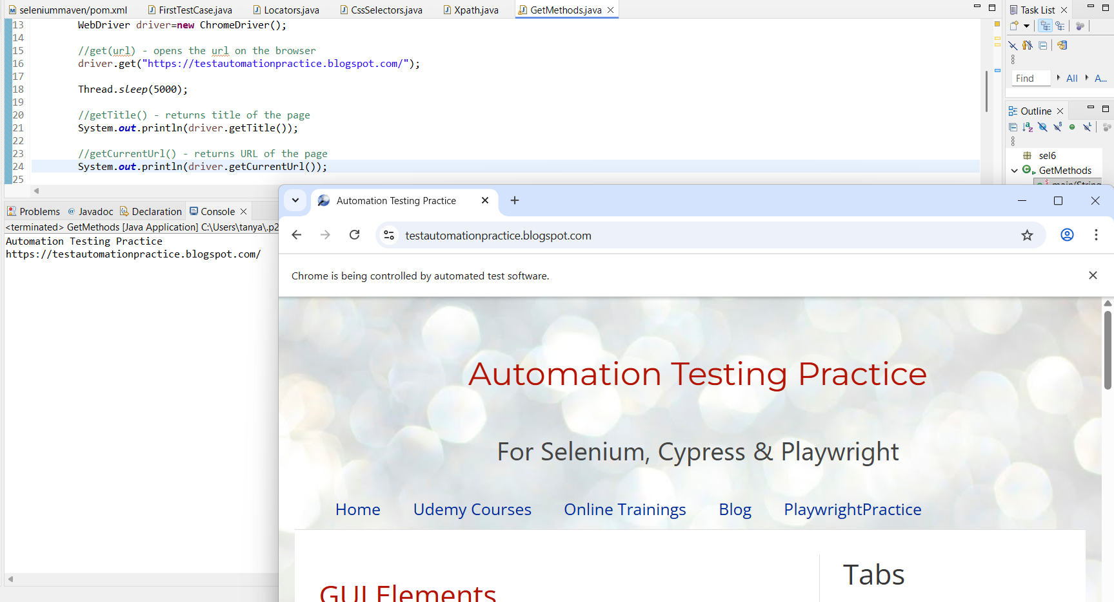

4) getPageSource()- returns source code of the page
System.out.println(driver.getPageSource());

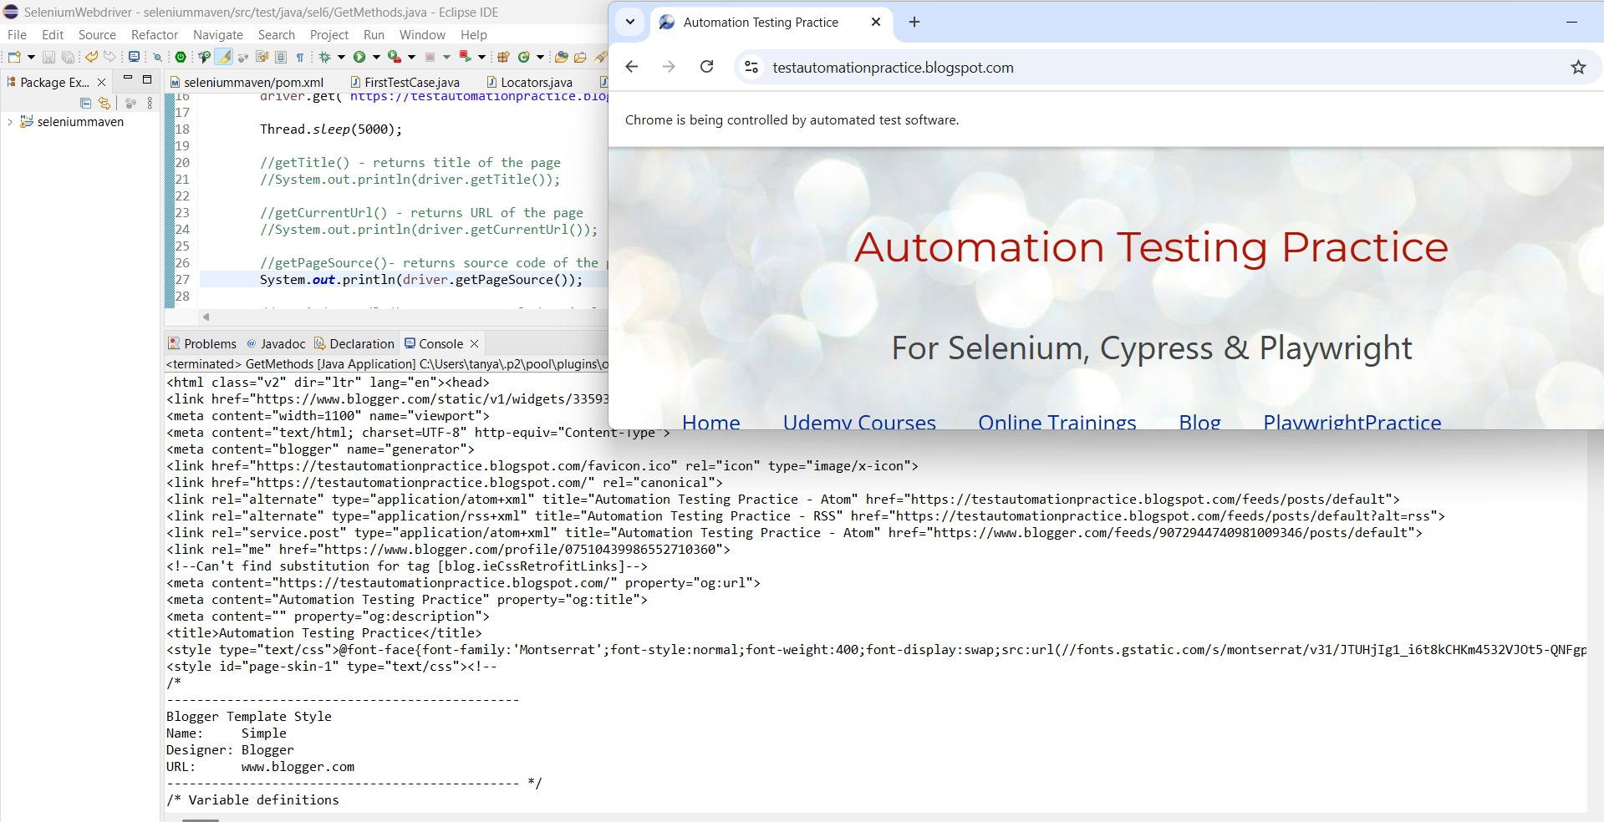

5) getWindowHandle() - returns ID of the single Browser window
String windowid=driver.getWindowHandle();
System.out.println("Window ID:"+ windowid);

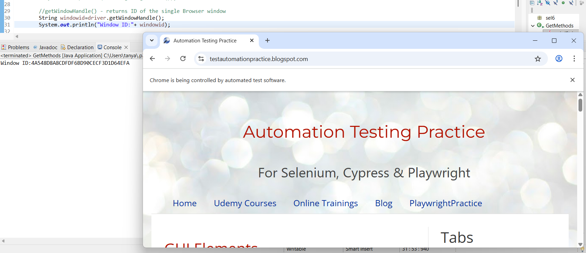
Window Id is dynamic in nature.

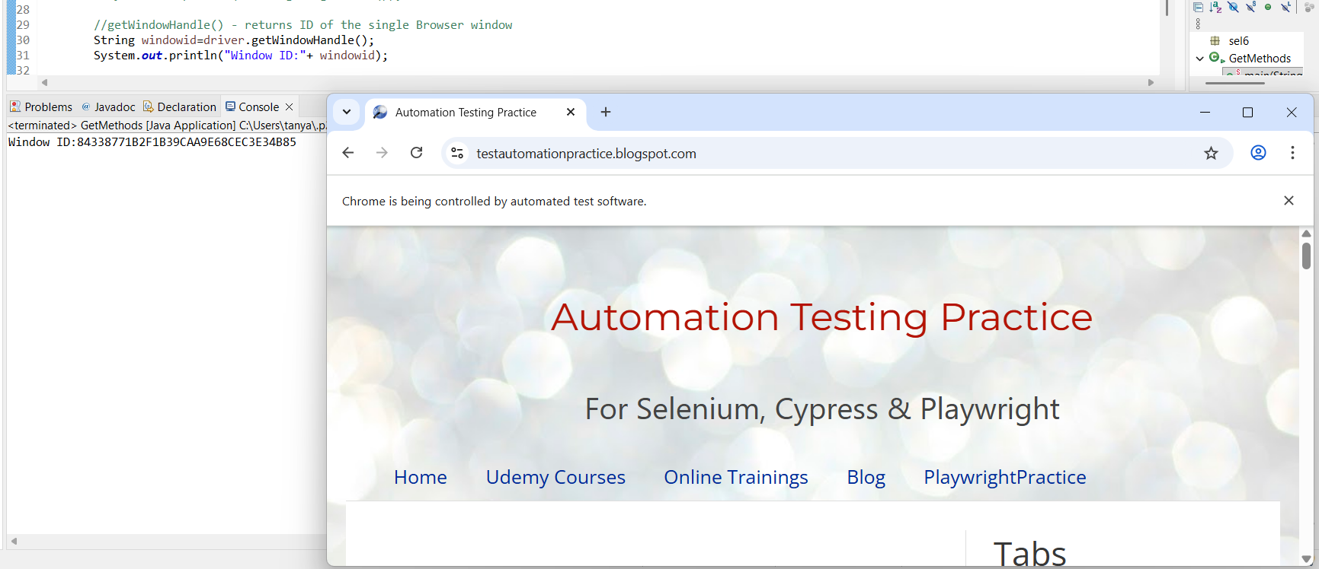

6) getWindowHandles() - returns ID's of the multiple browser windows

driver.findElement(By.linkText("merrymoonmary")).click(); // this will open new browser window
Set<String> windowids=driver.getWindowHandles();
System.out.println(windowids);

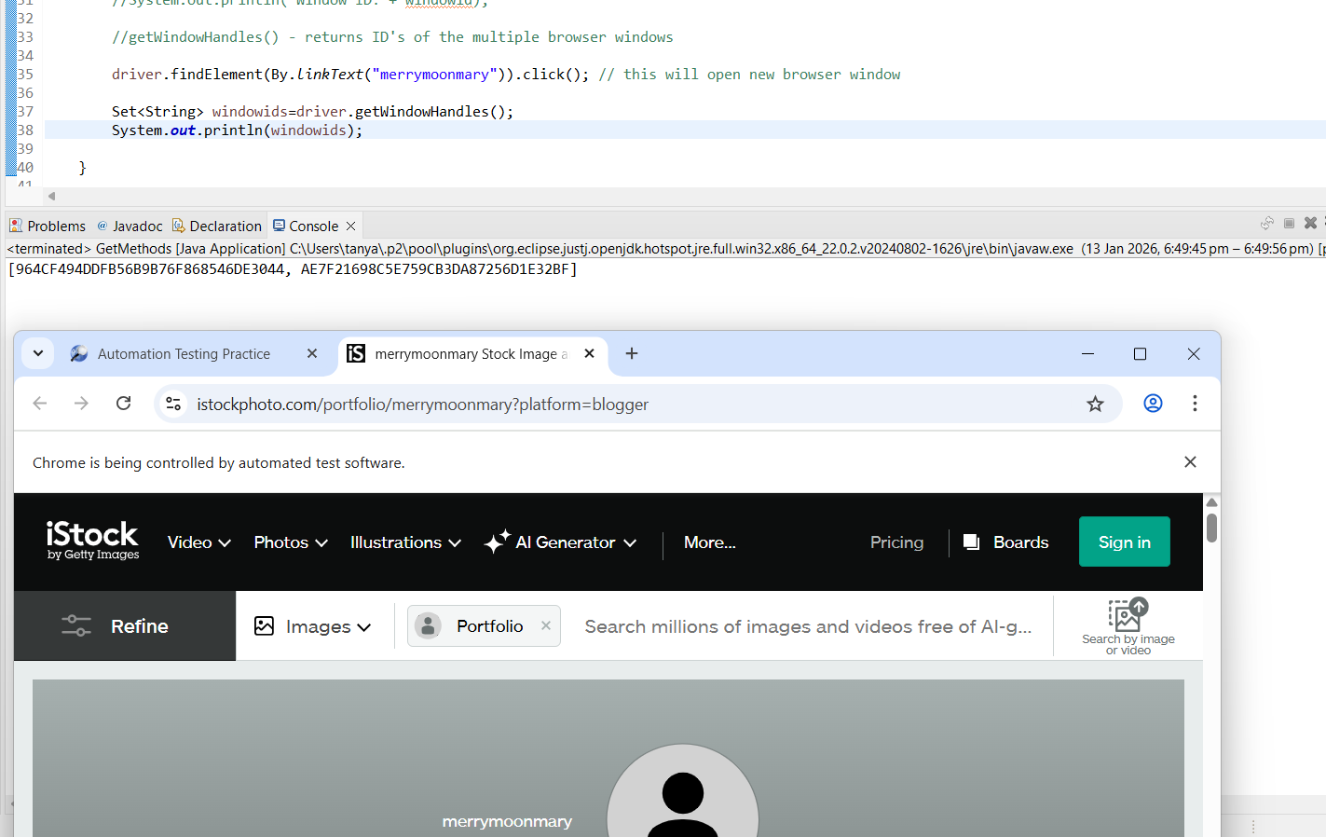

Conditional methods:
access these commands through WebElement; works on web elements.
returns boolean value( true/false)

isDisplayed() - we can check display status of the element
isEnabled() - we can check enable/disable status of the element/operational element like textboxes, radio button, checkboxes, buttons (not recommended for images, logos, labels as it's useless).
isSelected() - we can use to check the element is selected or not. Used on checkboxes, radio buttons, dropdown options.

1)isDisplayed()

WebElement logo=driver.findElement(By.xpath("//img[@class='wikipedia-icon']"));
System.out.println("Display status of logo:"+logo.isDisplayed());

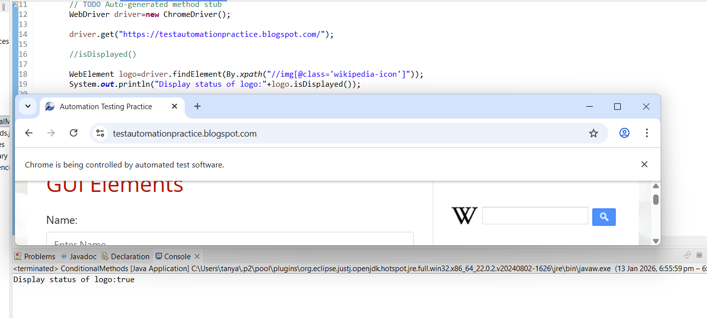

2) isEnabled()
boolean status=driver.findElement(By.xpath("//input[@id='Wikipedia1_wikipedia-search-input']")).isEnabled();
System.out.println("Enable status:"+status);

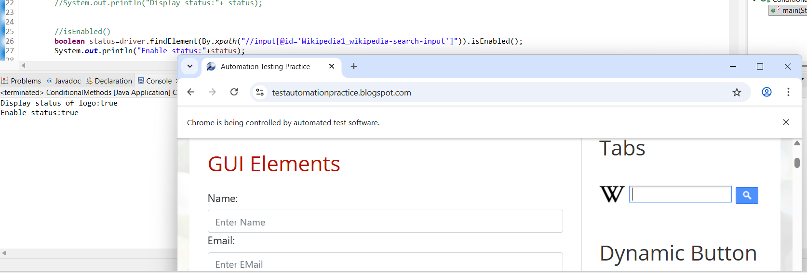

3) isSelected()

WebElement male_rd=driver.findElement(By.xpath("//input[@id='male']"));
WebElement female_rd=driver.findElement(By.xpath("//input[@id='female']"));

System.out.println("Before selection...............");
System.out.println(male_rd.isSelected()); //false
System.out.println(female_rd.isSelected()); //false

System.out.println("After selecting male...");
male_rd.click(); // select male radio button

System.out.println(male_rd.isSelected()); // true
System.out.println(female_rd.isSelected()); //false

System.out.println("After selecting female...");
female_rd.click(); // select female radio button

System.out.println(male_rd.isSelected()); // false
System.out.println(female_rd.isSelected()); //true

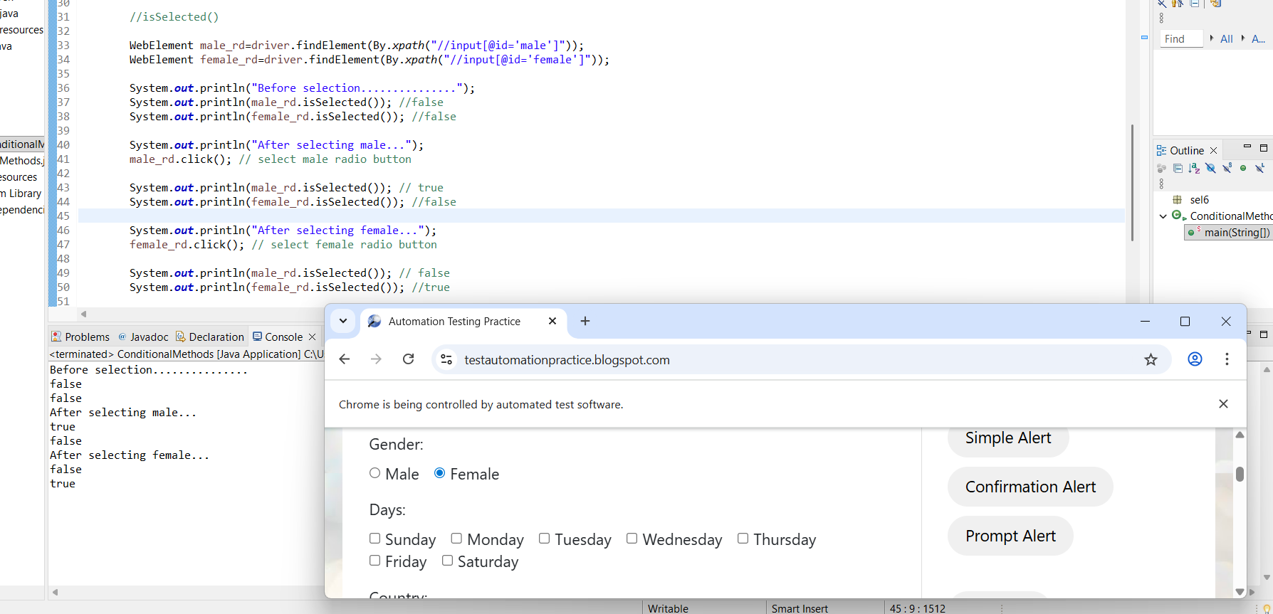

BrowserMethods:
close() - close single browser wherever the driver is focused (by default the driver is focused on origin browser only unless we navigate the driver through browsers)
quit() - close multiple browsers (all)
- close()
WebDriver driver=new ChromeDriver();
driver.get("https://testautomationpractice.blogspot.com/");
Thread.sleep(5000);
driver.findElement(By.linkText("merrymoonmary")).click(); // this will open new browser window

Thread.sleep(5000);
driver.close(); // close single browser window where ever the driver is focused

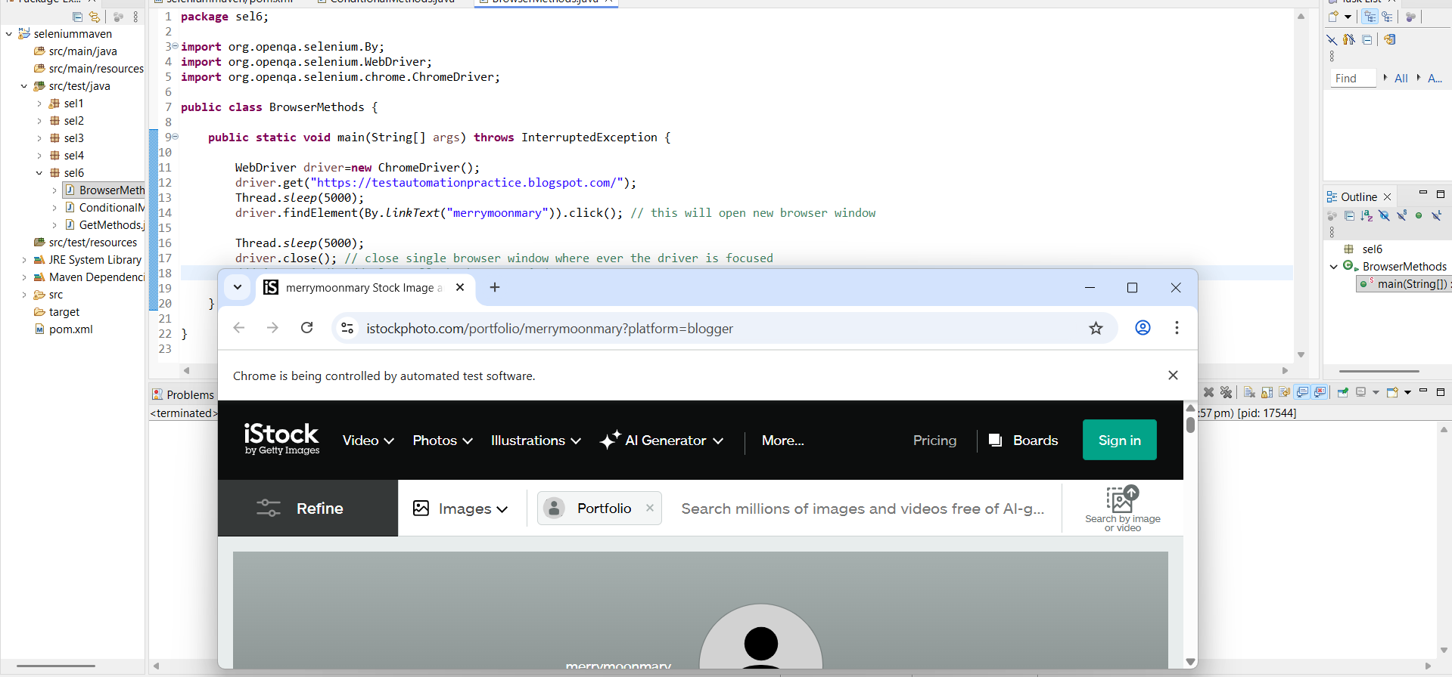

- quit()

WebDriver driver=new ChromeDriver();
driver.get("https://testautomationpractice.blogspot.com/");
Thread.sleep(5000);
driver.findElement(By.linkText("merrymoonmary")).click(); // this will open new browser window

Thread.sleep(5000);

driver.quit(); // close all the browser windows

